**Chapter 1: Introduction to Niryo Ned2**

Niryo Ned2 is a 6 DOF* robotic arm (as shown in Fig. 1.1.) that is based on Ubuntu 18.04 and ROS (Robot Operating System) Melodic which uses Raspberry Pi 4 (with 4GB of RAM) as its processor and can carry a maximum payload of 300 grams. The arm can be connected to a computer either using the RJ45 ethernet port on the back panel or using Wi-Fi.

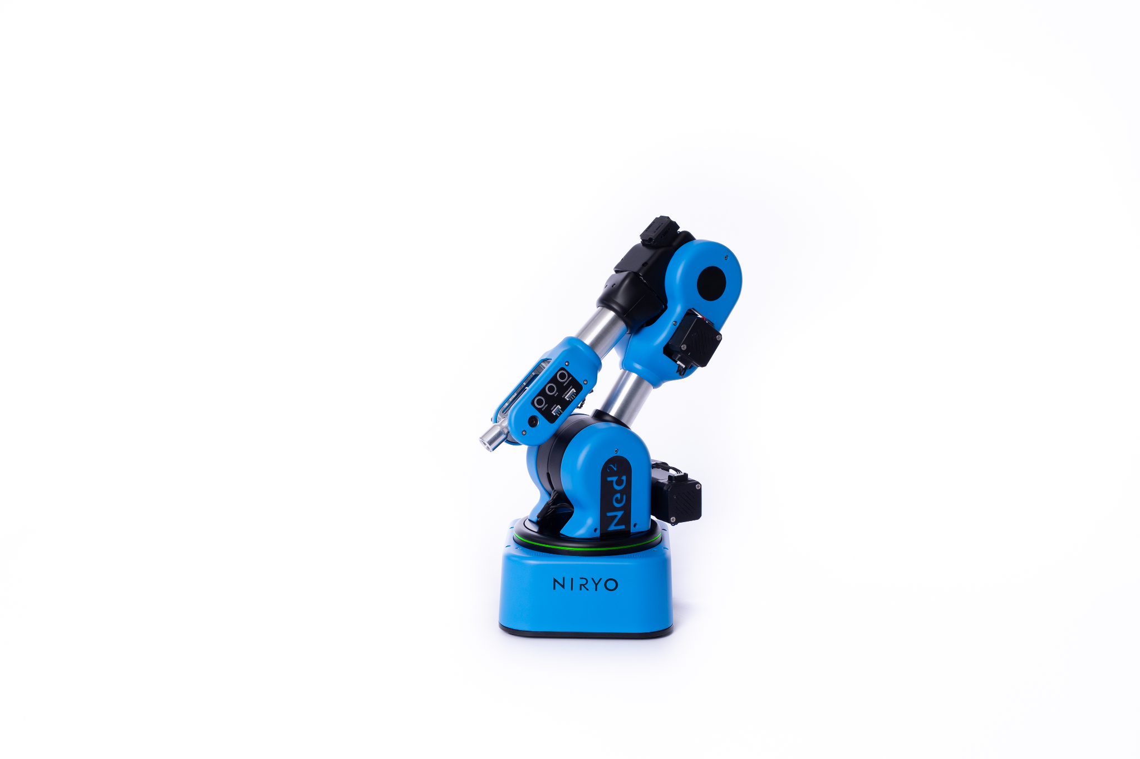

**Fig. 1.1. Niryo Ned2**

**1.A DOF/Axis**

In mechanics, degrees of freedom (DOF) is the number of independent variables that define the possible positions or motions of a mechanical system in space. DOF measurements assume that the mechanism is both rigid and unconstrained, whether it operates in two-dimensional or three-dimensional space. The number of degrees of freedom is equal to the total number of independent displacements or aspects of motion. In robotics, the term generally refers to the number of joints or axes of motion on the robot.

The movement that can be achieved along each DOF/axis is as follows:-

* **One axis**- can pick up an object and move it along a straight line
* **Two axis**- can pick up an object, lift it, move it horizontally and vertically, and set it down or present it – on one x/y plane – without changing the object’s orientation
* **Three axis**- can pick up an object, lift it, move it horizontally and vertically and set it down or present it – anywhere in x,y,z space within reach of the robot – without changing the object’s orientation
* **Four axis**- can pick up an object, lift it, move it horizontally and set it down or present it – in x,y, z space – while changing the object’s orientation along one axis (yaw for example)
* **Five axis**- can pick up an object, lift it, move it horizontally and set it down – in an x,y,z space – while changing the object’s orientation along two axis (yaw and pitch for example)
* **Six axis**- can pick up an object, lift it, move it horizontally and set it down – in an x,y,z space – while changing the object’s orientation along three axis (yaw, pitch and roll) as shown in Fig. 1.2.
* **Seven axis**- all of the movement capability of a six axis robot, along with the ability to physically move the robot from one place to another in a linear direction (typically horizontal motion along a rail).

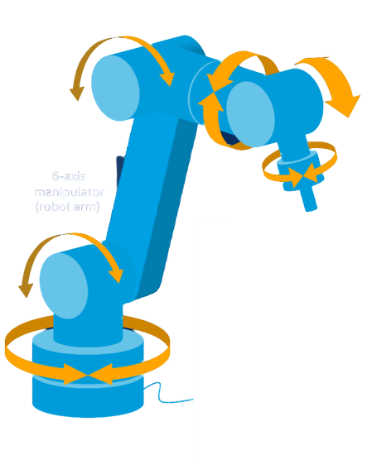

**Fig. 1.2. 6 DOF Robotic Arm**

**1.B Hardware Overview**

There are three buttons on the side panel of the robotic arm:-

* + **Freemotion** (highlighted in Fig. 1.3.) **:-** It deactivates the motors so that the arm can be moved manually even when it is powered on.

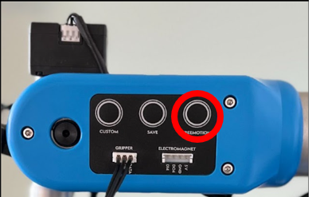

**Fig. 1.3. FREEMOTION Button**

* + **Save** (highlighted in Fig. 1.4.) **:-** It is used to save the current position of the arm which includes the x,y,z coordinates as well as Roll, Pitch and Yaw.

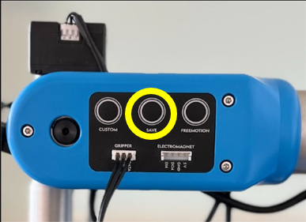

**Fig. 1.4. SAVE Button**

* + **Custom** (highlighted in Fig. 1.5.) **:-** Programmable button which can used to perform a given task.

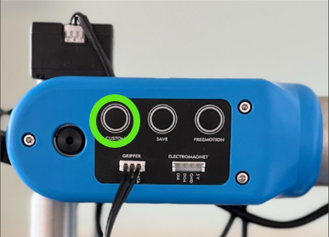

**Fig. 1.5. CUSTOM Button**

The arm also has an programmabel LED ring which can be used to determine the status of the arm at any given moment as shown in Fig. 1.6.

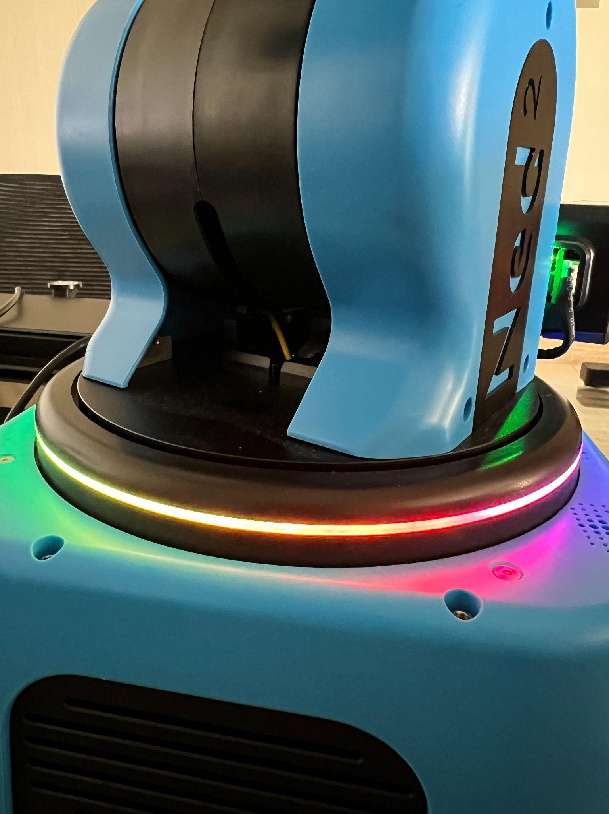

**Fig. 1.6. LED Ring**

The arm also has inbuilt speakers which can be used to play different sounds in accordance with the tasks being performed. The back and side panel of the arm houses multiple GPIO pins which can be used to connect accessories and attachements.

**1.B.1 Attachments**

The arm comes with 5 different end effectors which are as follows:-

* + Custom Gripper ( to pick up small objects) shown in Fig. 1.7.

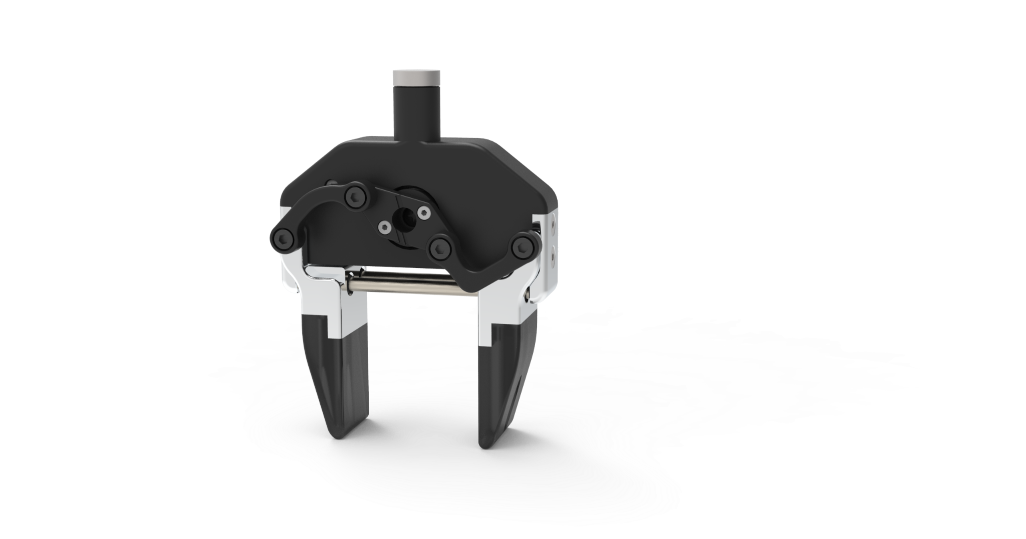

**Fig. 1.7. Custom Gripper**

* + Large Gripper (to pick up larger objects) shown in Fig. 1.8.

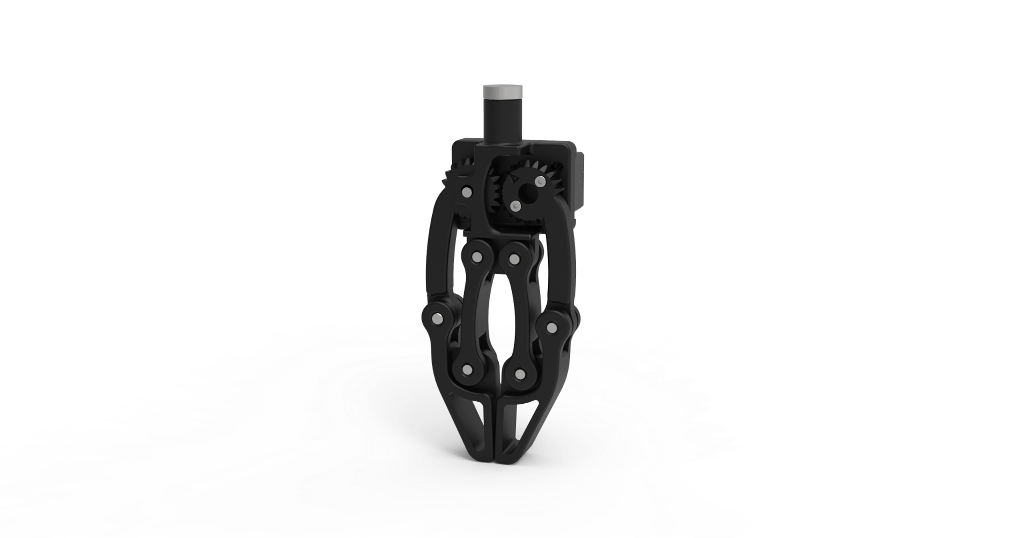

**Fig. 1.8. Large Gripper**

* + Adaptive Gripper (to pick up objects with complex and uneven surfaces) shown in Fig. 1.9.

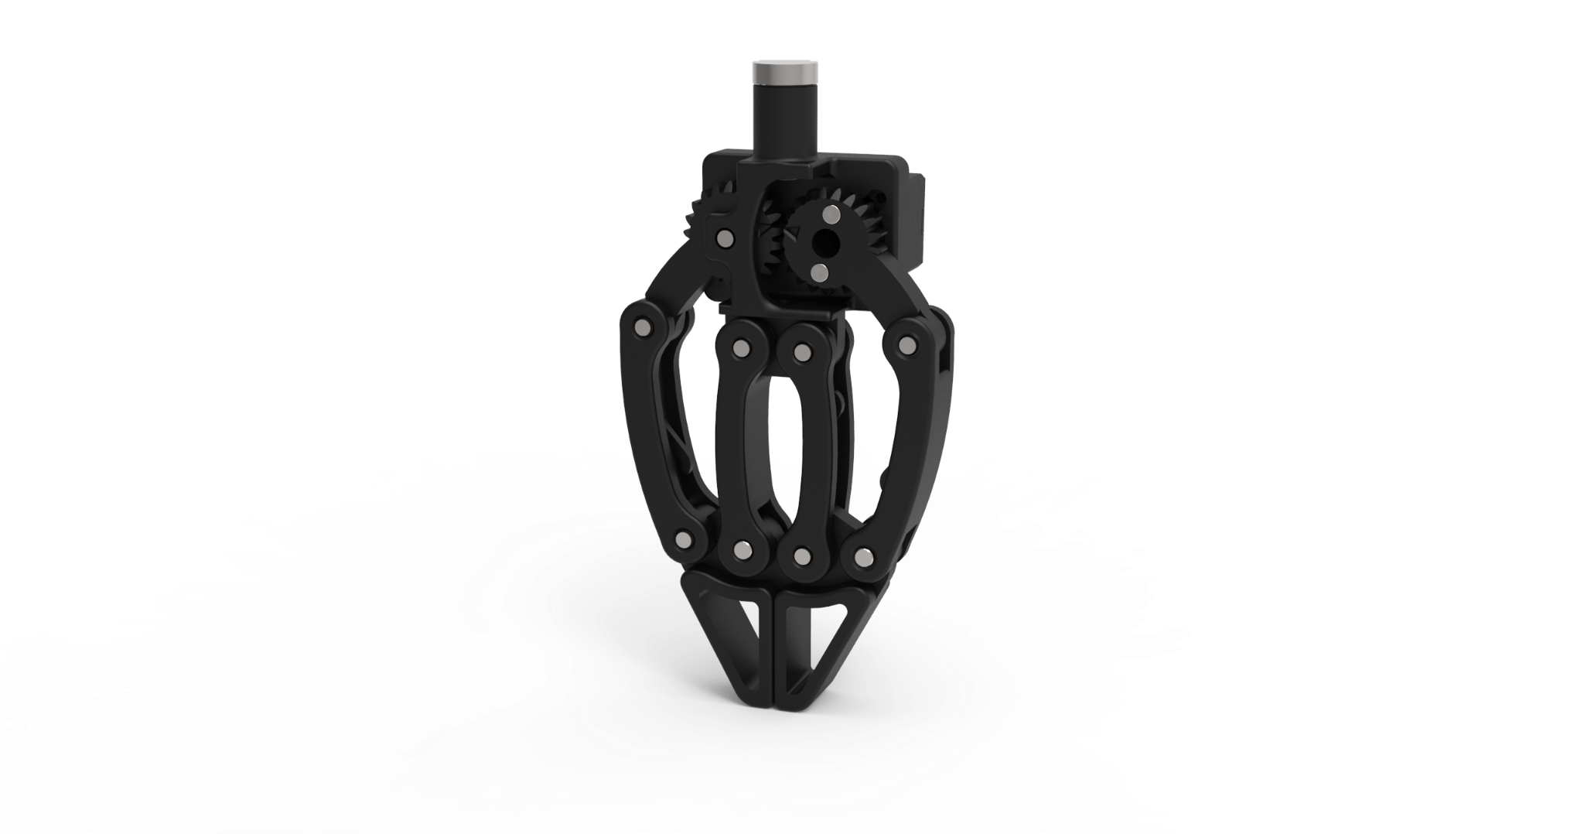

**Fig. 1.9. Adaptive Gripper**

* + Electromagnet (to segregate metallic from non-metallic objects) shown in Fig. 1.10.

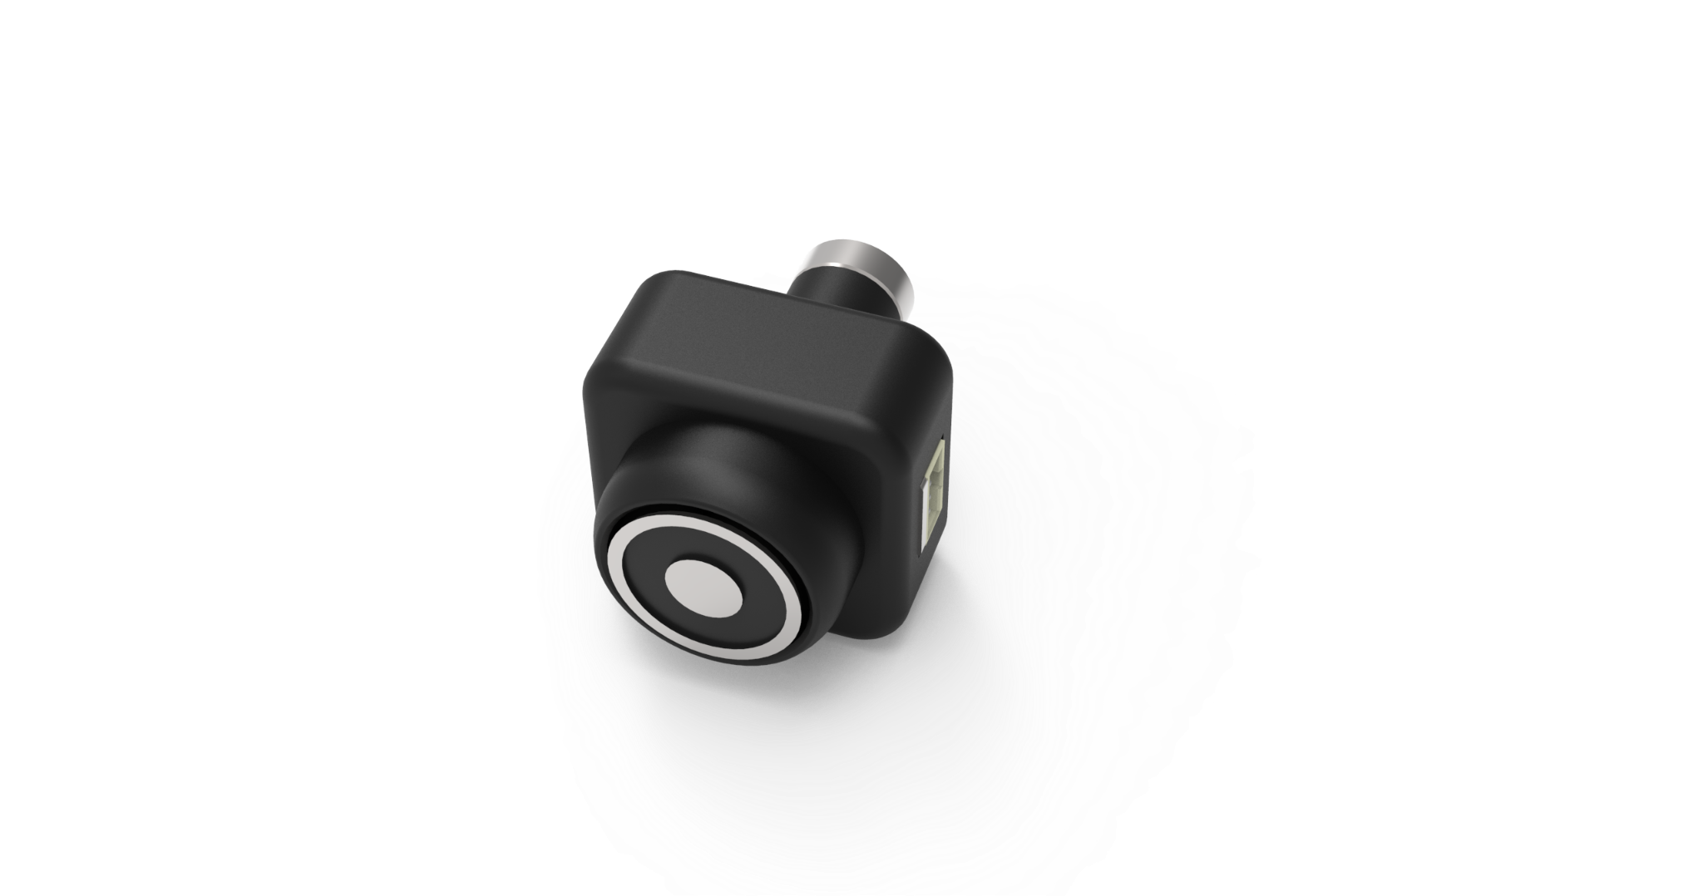

**Fig. 1.10. Electromagnet**

* + Vacuum Pump (to grab objects with plane and non-porous surfaces) shown in Fig. 1.11.

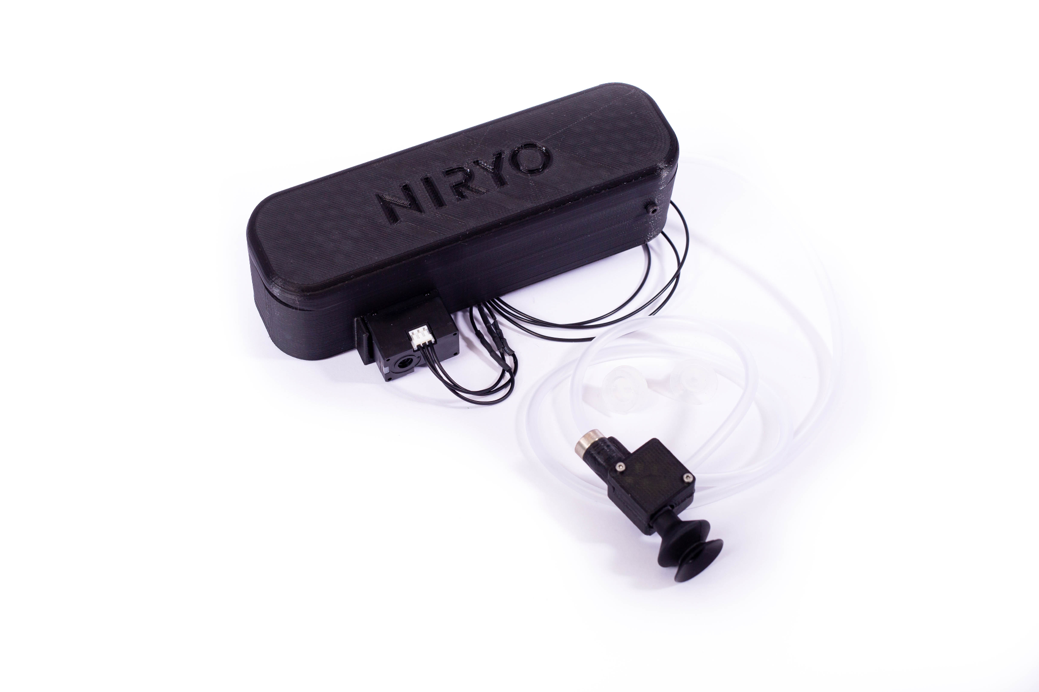

**Fig. 1.11. Vacuum Pump**

The arm also comes with three accessories:-

* + Vision Set (shown in Fig. 1.12.):- It consists of a camera that mounts beside the end effector and can be used to carry out image processing for color and object detection.

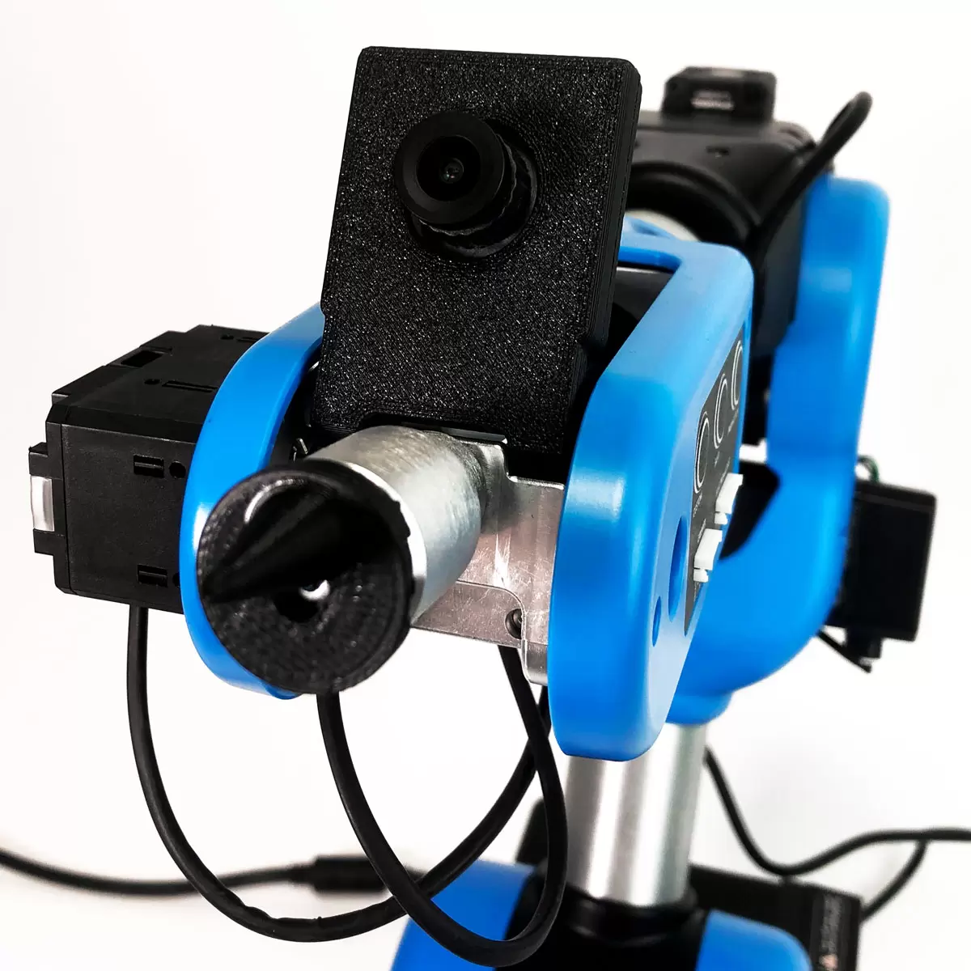

**Fig. 1.12. Vision Set**

* + Conveyor belt (shown in Fig. 1.13.) (with IR sensor and gravity feeder):- It can be used to simulate industrial scenarios like sorting of objects.

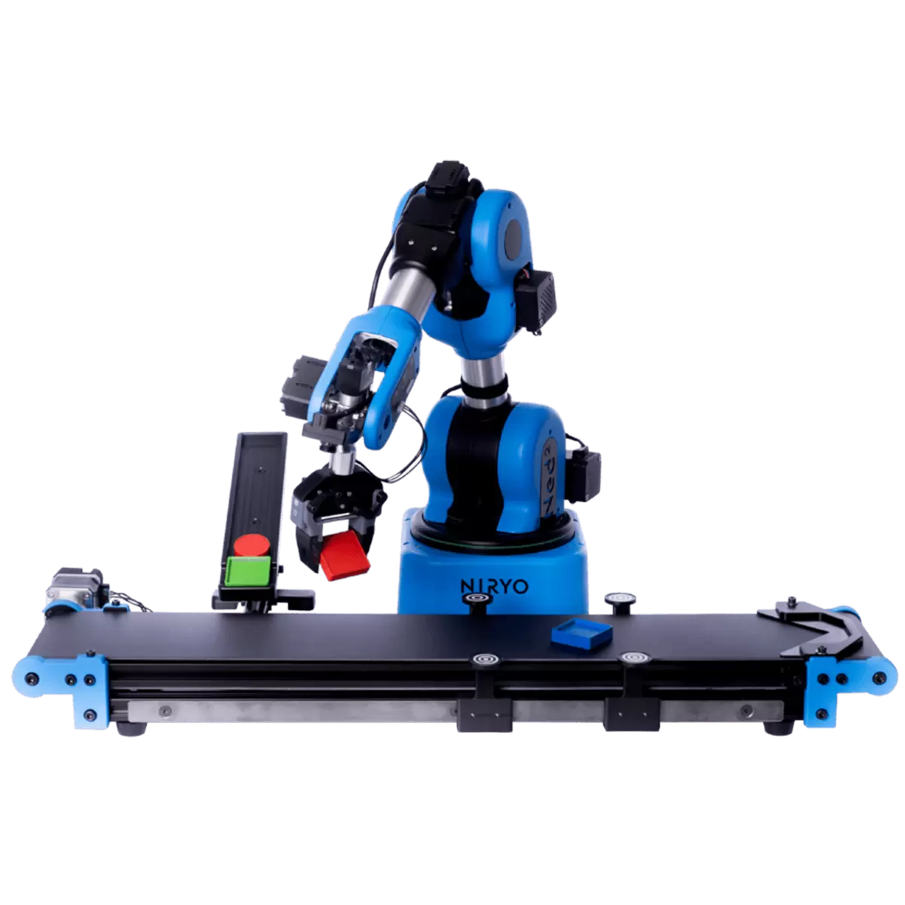

**Fig. 1.13. Conveyor Belt**

* + The IR sensor( shown in Fig. 1.14.) can further be used to stop the conveyor belt if it detects an object.

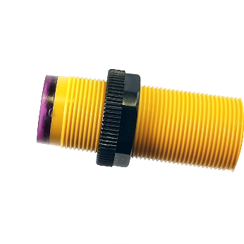

**Fig. 1.14. IR Sensor**

**1.B.2 Motor Specifications**

The arm uses a combination of Stepper and Servo motors for actuation. Each joint is also equipped with a voltage and temperature sensor and the readings can be accessed using the Niryo Studio application. The specification of all the integrated motos are tabulated in table 1.1

**Table 1.1 Motor Specification**

| **Joint (starting from the bottom of the robotic arm)** | **Motor** | **Input Voltage** | **Torque** | **Operating Temperature** |
| --- | --- | --- | --- | --- |
| 1 | NEMA 17 Stepper | 12V | Holding Torque: 1.3-31 kg-cm | -10 ~ +40 °C |
| 2 | NEMA 17 Stepper | 12V | Holding Torque: 1.3-31 kg-cm | -10 ~ +40 °C |
| 3 | NEMA 17 Stepper | 12V | Holding Torque: 1.3-31 kg-cm | -10 ~ +40 °C |
| 4 | XL430 Servo | 6.5~12.0V (11.1V recommended) | Stall Torque: 14 kg-cm | -5 ~ +72 °C |
| 5 | XL430 Servo | 6.5~12.0V (11.1V recommended) | Stall Torque: 14 kg-cm | -5 ~ +72 °C |
| 6 | XL330 Servo | 3.7~6V (5V recommended) | Stall Torque: 5.3 kg-cm | -5 ~ +60 °C |
| End Effector | XL330 Servo | 3.7~6V (5V recommended) | Stall Torque: 5.3 kg-cm | -5 ~ +60 °C |
| Conveyor | NEMA 17 Stepper | 12V | Holding Torque: 1.3-31 kg-cm | -10 ~ +40 °C |

**1.B.3 Torque**

Torque is a measure of a force's ability to cause rotational motion around an axis or pivot point.

**Open torque-** The torque at which the end effector opens.

**Open hold torque-** The torque at which the end effector stays after opening.

**Closing torque -**The torque at which the end effector closes.

**Closing hold torque-** The torque at which the end effector stays after opening.

**1.B.4 Camera Specification (for Vision Set)**

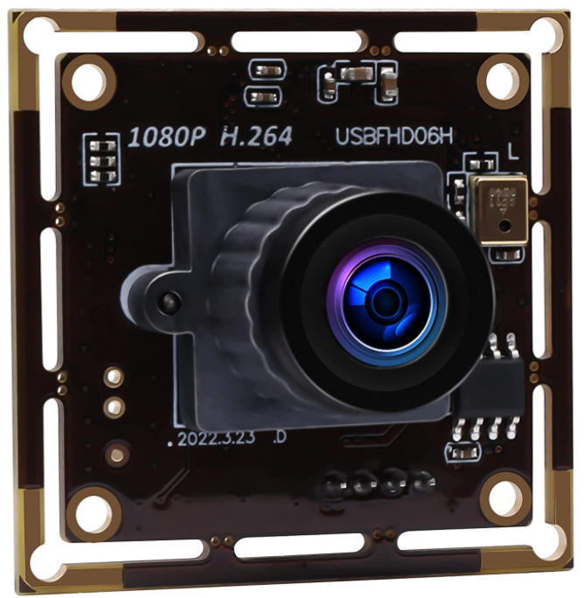

**Fig. 1.15. ELP-USBFHD06H-L21 Camera**

Niryo Ned2 uses an ELP (Model No:- ELP-USBFHD06H-L21) 2MP camera as seen in Fig. 1.15. with Sony IMX322 sensor and 2.1mm lens and can record 1920×1080p at 30fps.

**1.C Applications of Pick and Place Robotic Arm in industrial/consumer space**

* Assembly:- Pick and place robots used in assembly applications grab incoming parts from one location, such as a conveyor, and place or affix the part on another piece of the item. The two joined parts are then transported to the next assembly area.
* Packaging:- Robotic arms used in the packaging process grab items from an incoming source or designated area and place the items in a packaging container.
* Bin picking:- In bin picking applications, pick and place robots are employed to extract parts or items from bins. These robots are equipped with sophisticated vision systems that enable them to accurately identify and select the appropriate items based on color, shape, and size, even when the bins contain a random mixture of items. Subsequently, these parts or items are transported to another location for assembly or packaging.
* Inspection:- In inspection applications, pick and place robots are equipped with state-of-the-art vision systems that enable them to effectively grasp objects, identify anomalies, and eliminate defective parts or items by relocating them to a specified area.
* Part sorting:- By harnessing vision inspection technology, pick and place robots have the capability to sort and choose parts based on specific attributes such as shape, size, color, location, or barcode. They can then accurately position the part in the designated location and ensure it is oriented correctly.

**1.D Benefits of pick and place robots**

* Productivity:- Due to a higher speed of operation, a pick and place robot has higher productivity than its human counterpart. This is why modern manufacturing environments are able to roll out a higher number of products, to increase production rates.
* Uninterrupted Production:- Human workers require breaks, which can lead to interruptions in the production line. Interruptions also occur during the change of shift of workers. However, robots do not require breaks and can work all day and night.
* Consistency:- Human labor always brings in the factor of human error. However, a pick and place robot will work on exact mathematical principles, so there are no errors and the end result is a consistent operation.
* Safety:- Lifting objects involves the risk factor of the object falling down on human workers and causing injuries. However, robots have no such risk, leading to higher safety in the workplace.
* Return on Investment:- The utilization of pick and place robots allows companies to reduce operational expenses through a modest initial investment. This eliminates the need for paying salaries and benefits, resulting in a greater return on investment in manufacturing operations.
* Throughput:- Pick and place robots enhance productivity by achieving a greater throughput within a specified timeframe. Fast pick robots, for example, can efficiently move items at a rate of 300 SKUs per hour.

**Chapter 2: Initial Startup and Setup Procedure**

**2.A Niryo Ned2 startup and connecting to Niryo Studio**

* Press the power button on the back panel of the robotic arm to switch it on as shown in Fig. 2.1.

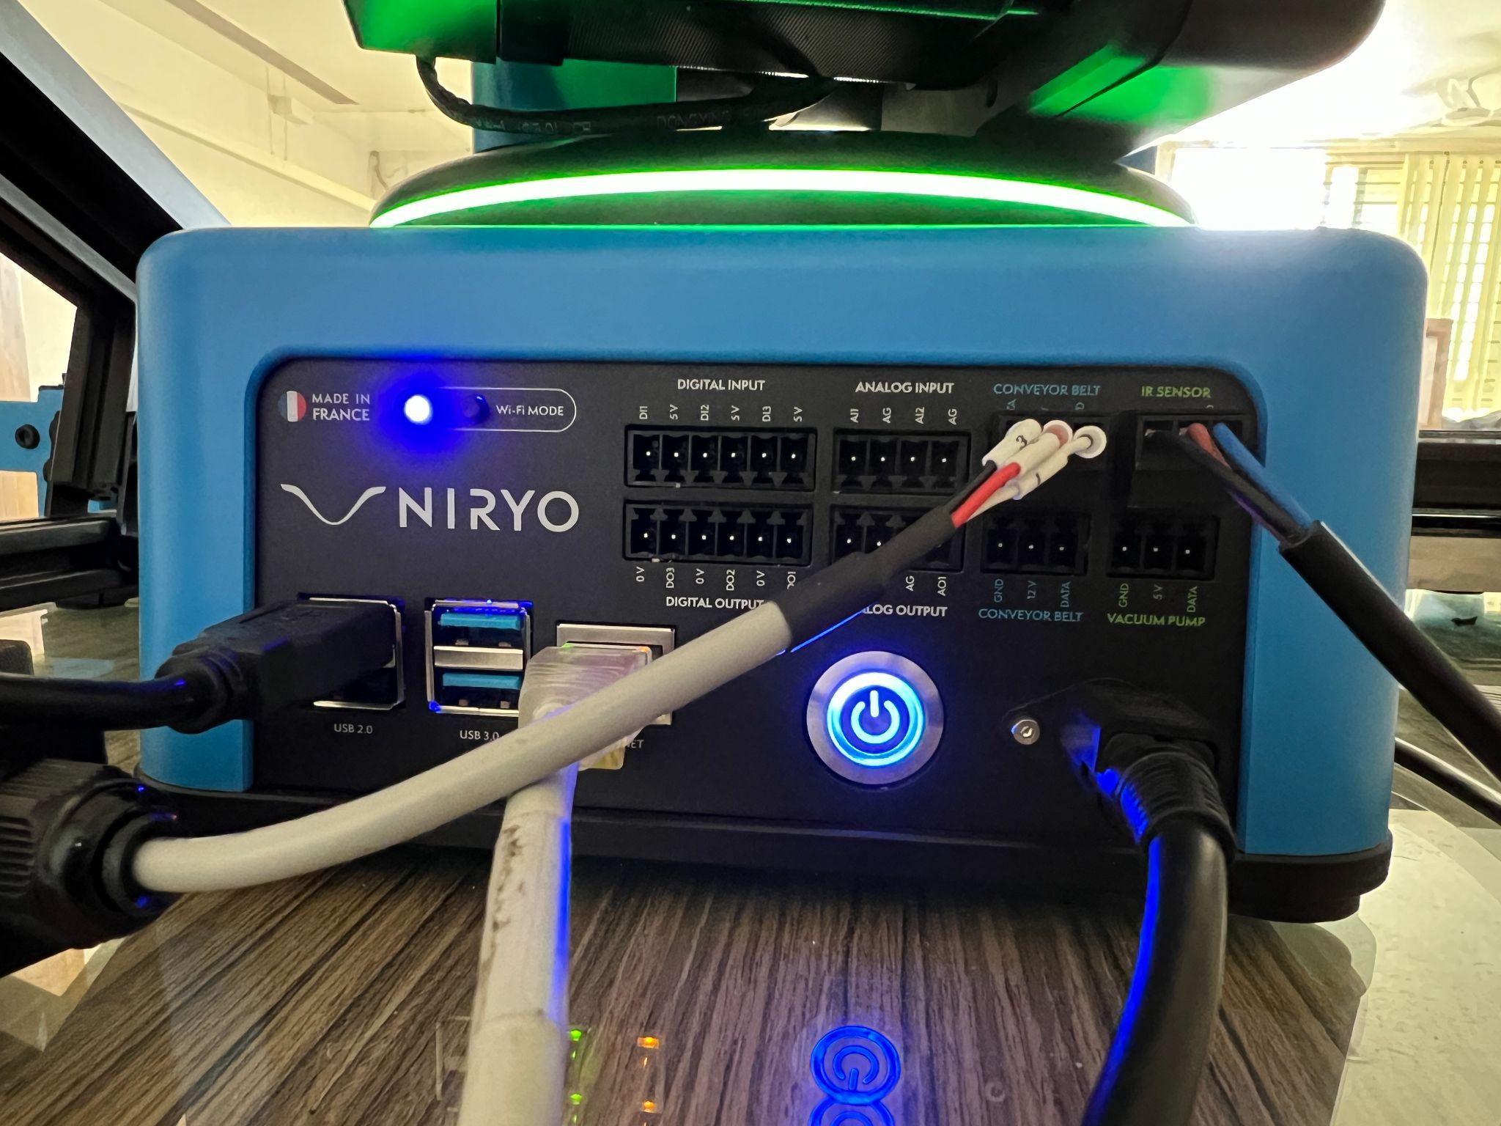

**Fig. 2.1. Back Panel of Niryo Ned2**

* In Figure 2.1, it can be observed that an Ethernet connection has been employed to connect the robotic arm with the PC.
* After approximately one to two minutes, the robotic arm (during this period, the LED ring will be illuminated in white) will emit a start-up sound, signifying that the arm is prepared for connection and operation. Subsequently, the LED ring will transition to a blue color, as illustrated in Figure 2.2.

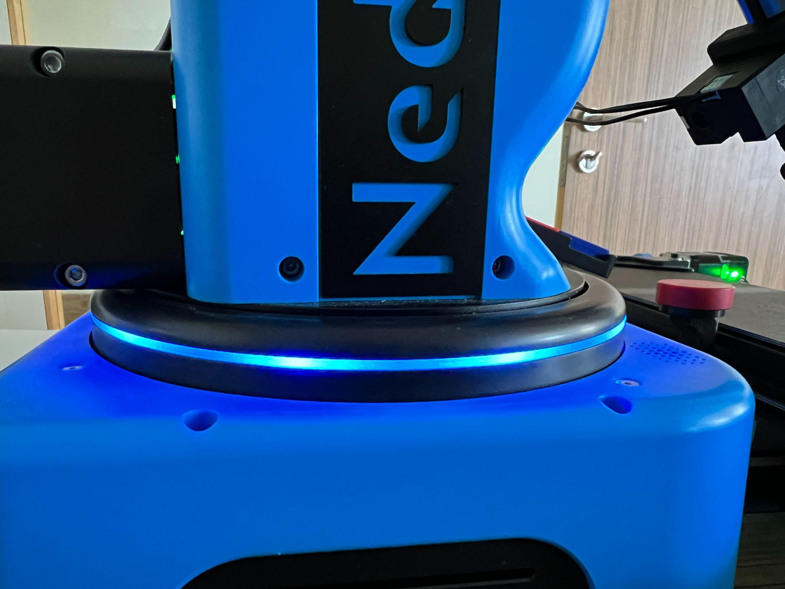

**Fig. 2.2. LED Ring**

* Launch the Niryo Studio Application on the computer and select the arrow icon located in the upper right corner, as depicted in Figure 2.3.

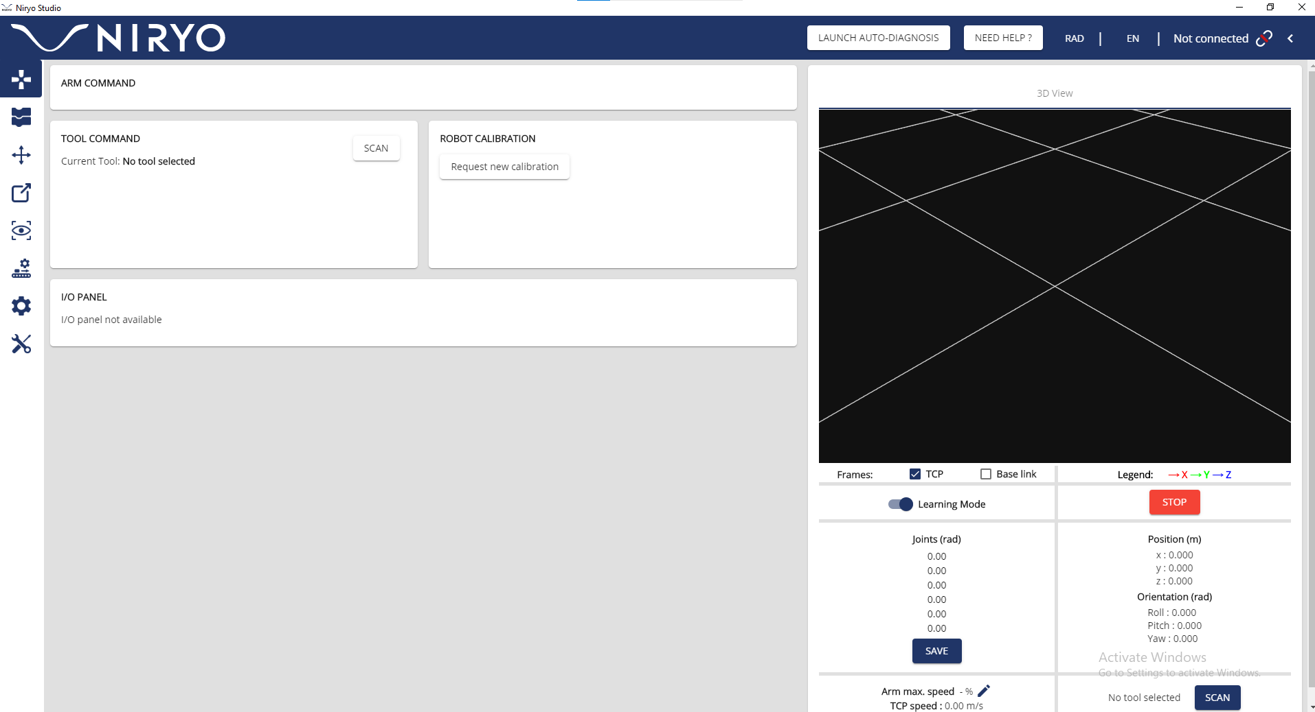****

**Fig. 2.3. Connection Button**

* Select “Niryo Robot Ethernet (default IP)” (as shown in Fig. 2.4.) from the drop down menu if using Ethernet connection.

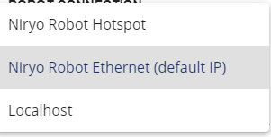

**Fig. 2.4. Drop Down Menu**

* Click the “Connect to Niryo Robot” button (as shown in Fig. 2.5.) to establish connection with the arm.

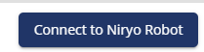

**Fig. 2.5. Connection Button**

* Fig. 2.6. will be displayed in Niryo Studio if connection is successfully established.



**Fig. 2.6. Connection Established**

* To initiate the automatic calibration of the robotic arm, click on the "Calibration Needed" button, as indicated in Figure 2.7. Once the calibration process is completed, the LED ring will switch to a green color, and the robotic arm will move to its designated position.



**Fig. 2.7. Auto Calibration Button**

* In Figure 2.8, you can observe the digital twin representation of the robotic arm displayed under the "3D View" section. Additionally, the live stream from the vision set can be viewed in the "Camera Streaming" section.

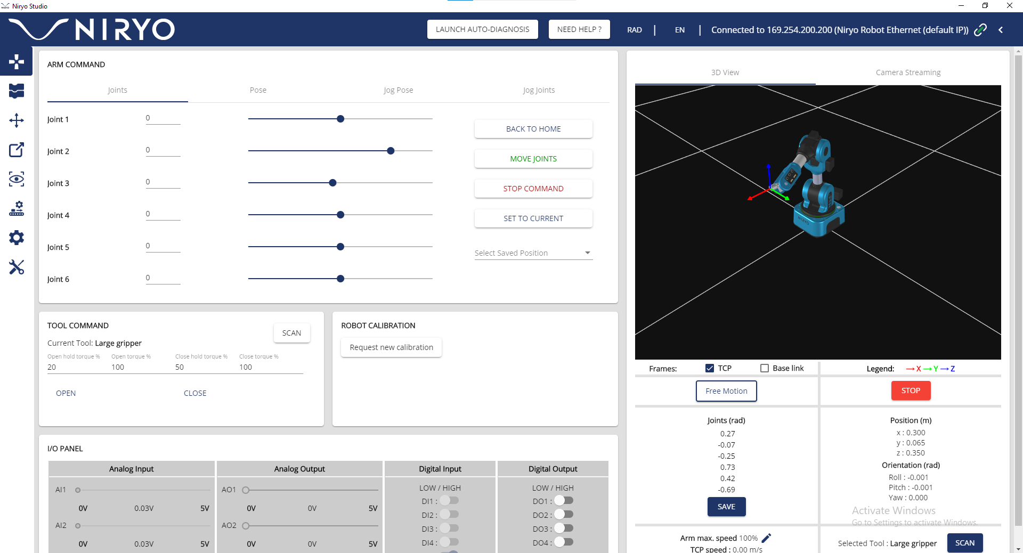

**Fig. 2.8. Niryo Studio after connection with robotic arm**

* Navigate to the Settings Menu (left side of Niryo Studio) and under “ROBOT TCP (TOOL CONTROL POINT)” (shown in Fig. 2.9.) click the “SCAN” button to equip the end effector. After it displays the selected tool, turn on “ENABLE TCP” which will give the position and orientation of the end effector as shown in Fig. 2.10.

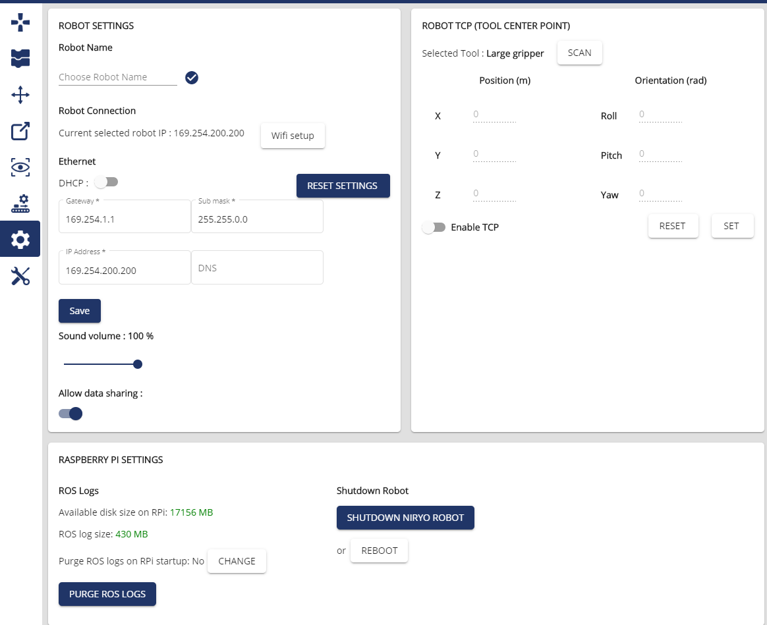

**Fig. 2.9. Settings Menu in Niryo Studio**

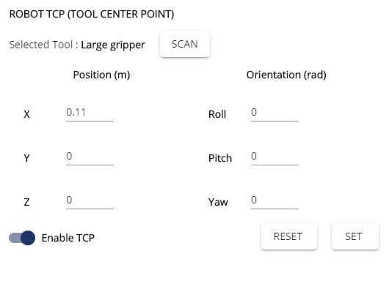

**Fig. 2.10. Position and Orientation of End Effector**

* The robotic arm has now been set up and calibrated completely and can now be used as per the requirements of the user.

**2.B. Blockly Coding**

* Use the left panel of Niryo Studio and navigate to the screen as shown in Fig. 2.11. This is the Blockly code editor window (blocks of code are available under the sub menus Logic, Loops etc.)

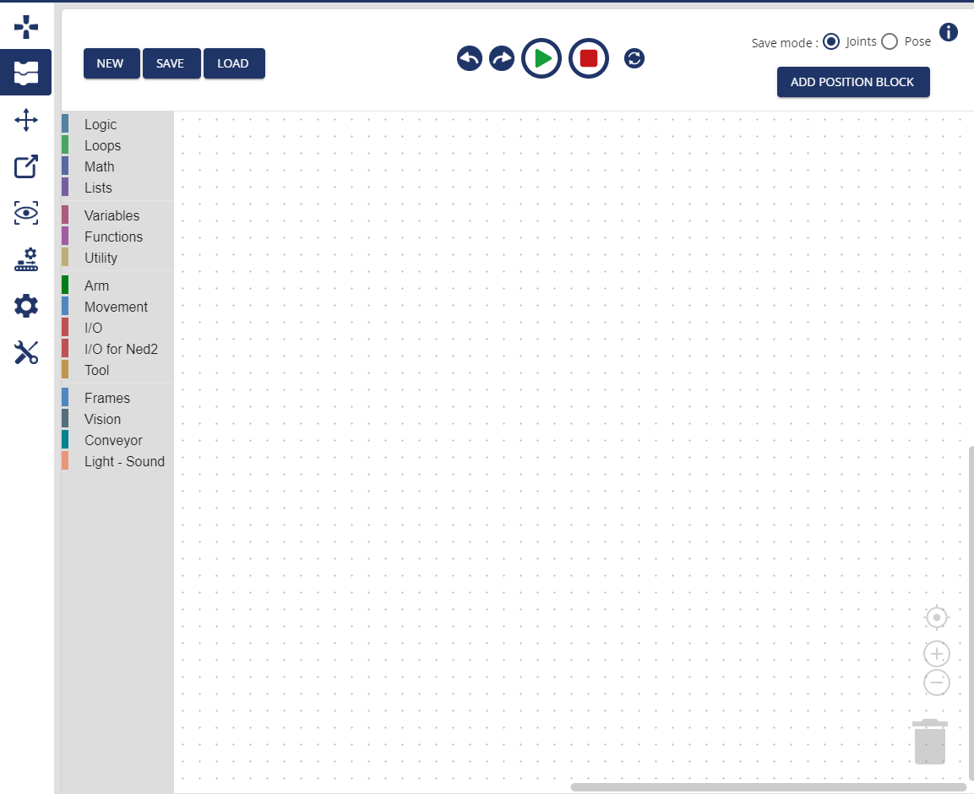

**Fig. 2.11. Blockly code editor window**

* The “NEW” button can be used to clear the editor and start a new code.
* The “SAVE” button is used to save the current program in the computer.
* The “LOAD” button is used to load a previously saved program.

**2.D Vision Set, Conveyor Belt, IR Sensor Setup**

* Fix the camera near the end effector as shown in Fig 1.12. and plug it into one of the USB ports on the back panel as shown in Fig. 2.1. Similarly connect the Conveyor belt and the IR sensor to the GPIO ports labeled as “CONVEYOR BELT” and “IR SENSOR” on the back panel of the robotic arm as shown in Fig. 2.1.
* Click the “SCAN” button under the “CONVEYOR BELT CONTROL” section in Niryo Studio as shown in Fig. 2.12.
* The connected conveyor belt will show up and its speed and direction can also be controlled from here. Furthermore, it can also be used to stop the conveyor belt at any given point of time.

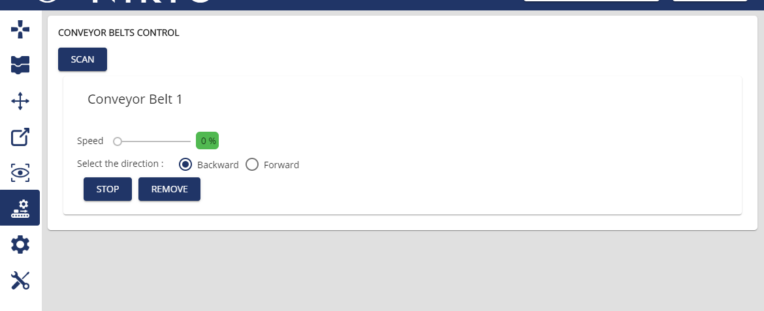

**Fig. 2.12. Conveyor Belt Control**

* IR Sensor can be read using the Digital Input pin DI5 (as shown in Fig 2.13.) Refer Fig. 2.8. to navigate to the “Digital Input” section.

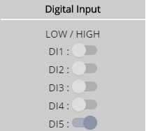

**Fig. 2.13. Digital Input Pins**

* A camera stream will be visible under the “Camera Streaming” section in Niryo Studio after the Vision set has been successfully connected as seen in Fig. 2.14.
* “Filters” can be used to highlight a specific color (red, blue, green) or all 3 colors (select “Any”). Select “Landmarks” to set up a correct observation position (Refer Chapter 4).

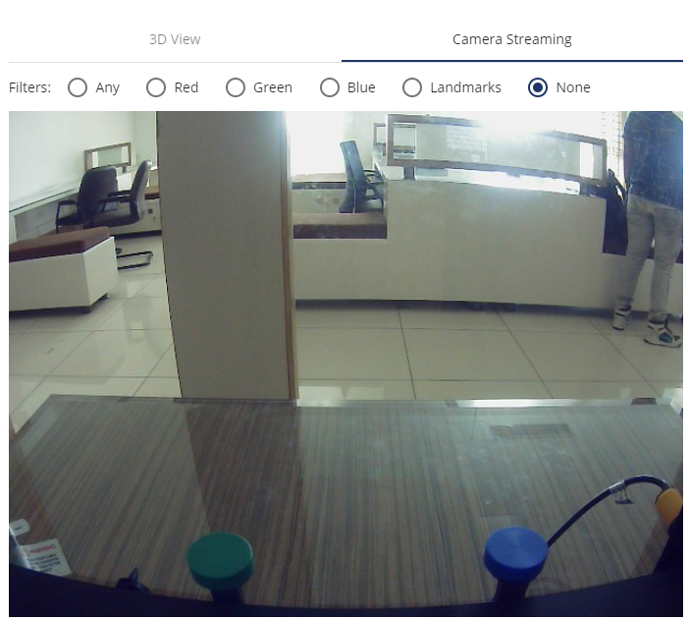

**Fig. 2.14. Camera Stream**

* Once the camera has been configured, it is necessary to establish a workspace and calibrate the arm to operate within that workspace. This enables the camera to effectively detect objects of varying shapes, colors, and types. Follow the instructions provided below for the calibration and setup process.

**2.E Workspace Calibration for Vision Set**

* Equip the workspace tool (shown in Fig. 2.15.) to the robotic arm.

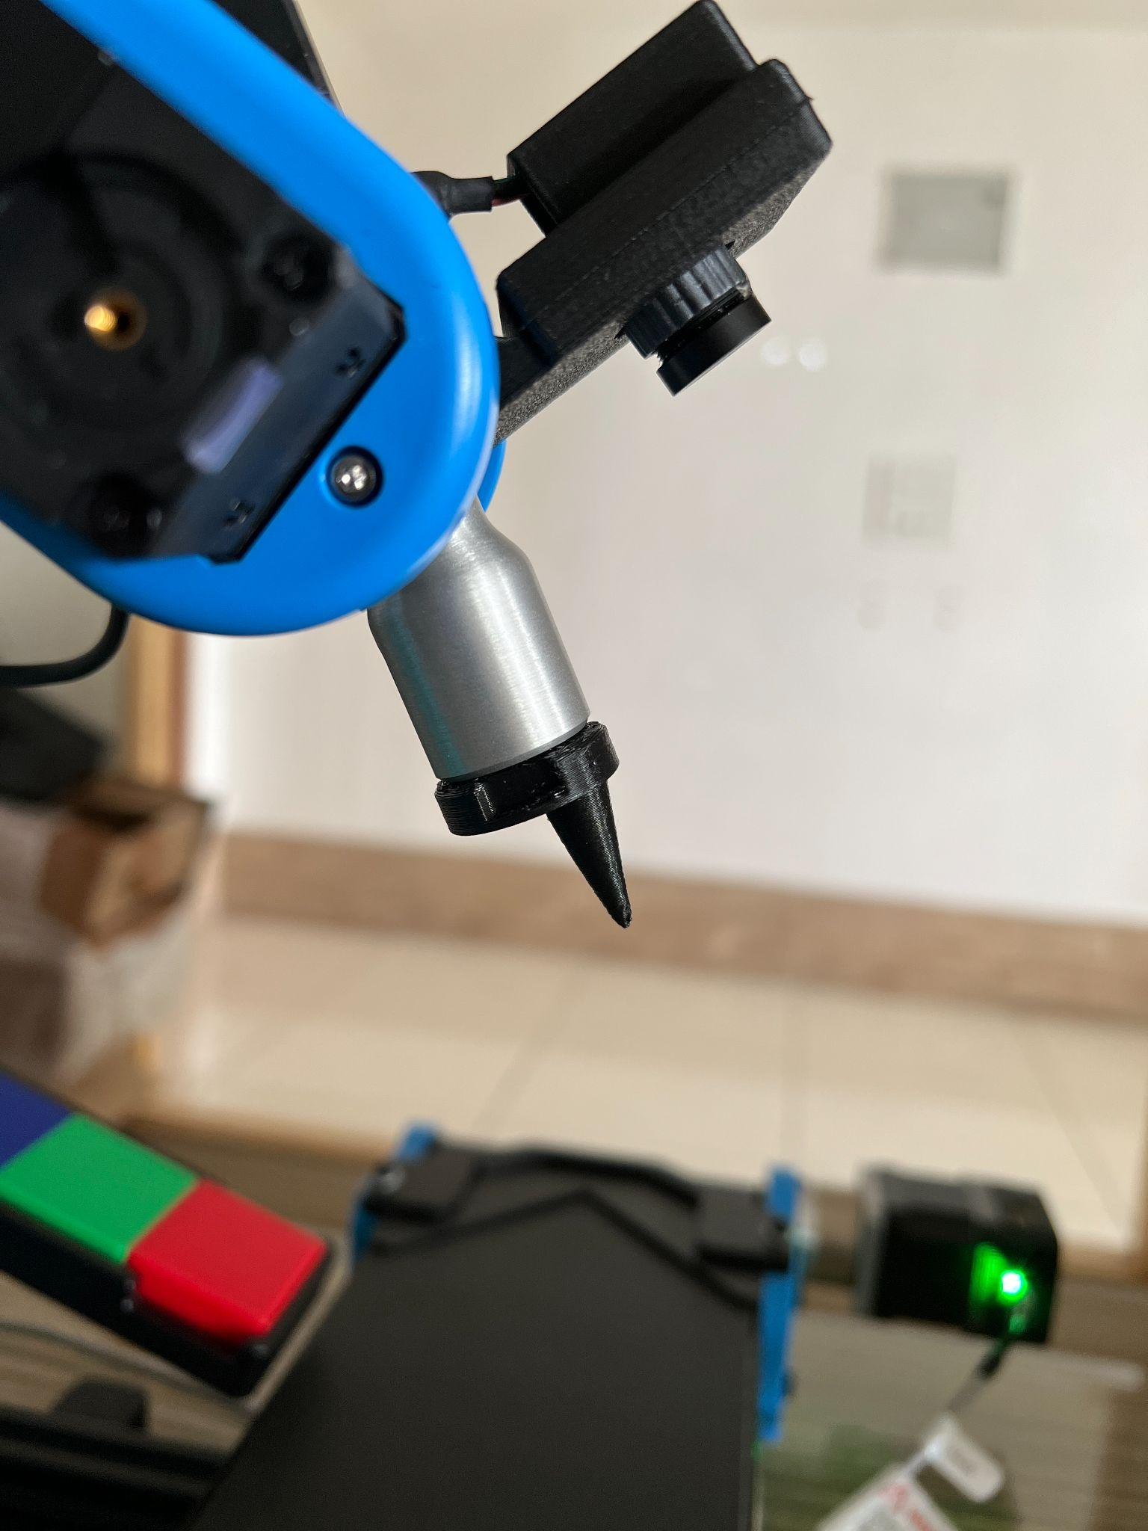

**Fig. 2.15. Workspace tool equipped as the end effector**

* Navigate to the “WORKSPACES” tab in Niryo Studio shown in Fig. 2.16. and click the “+” icon to add a workspace.

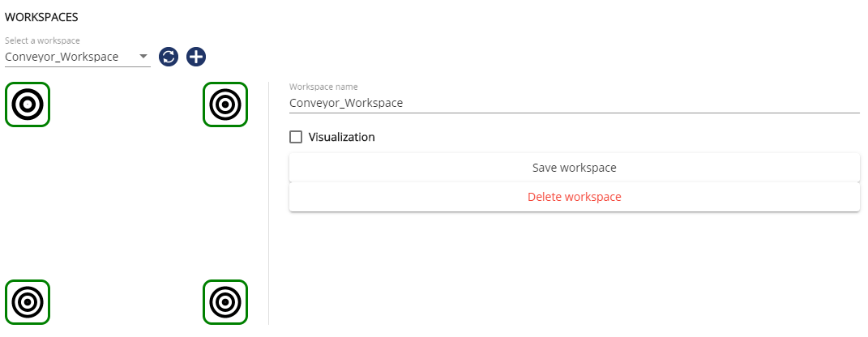

**Fig. 2.16. WORKSPACES Tab in Niryo Studio**

* Place the tool exactly in the center of the top left landmark similar to Fig. 2.17. and Fig. 2.18. and save the position.

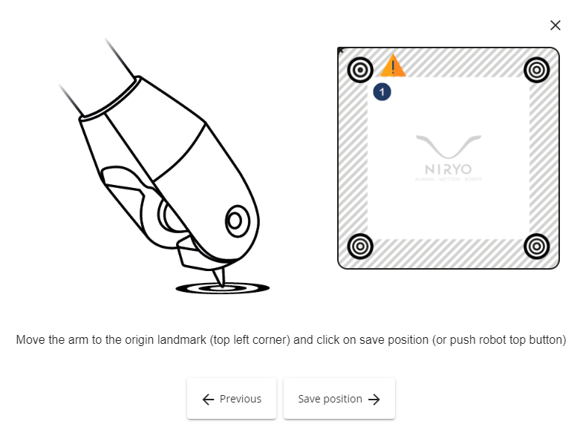

**Fig. 2.17. Steps to be followed in Niryo Studio**

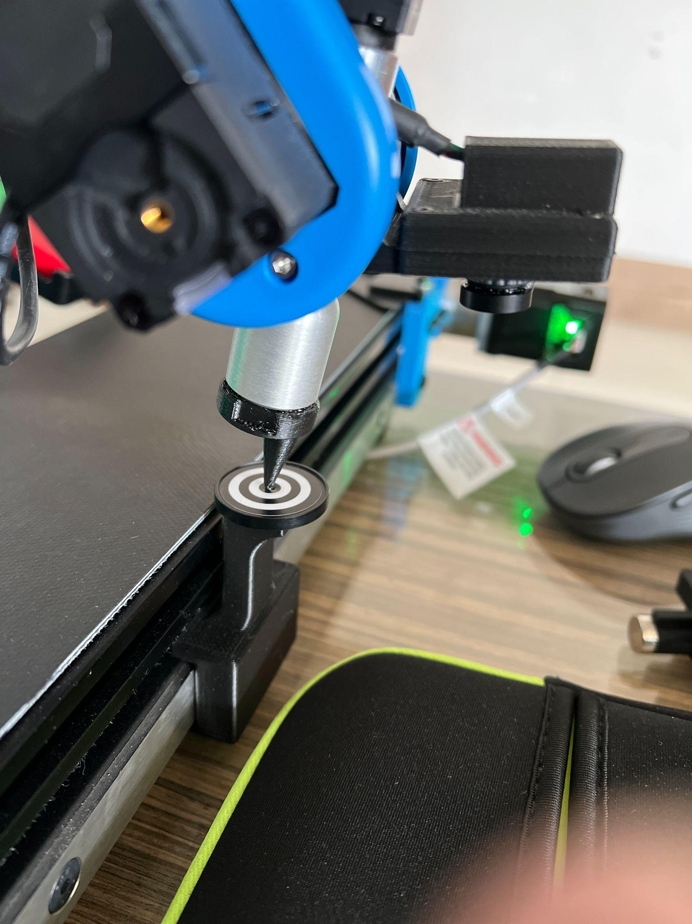

**Fig. 2.18. Workspace tool placed exactly in the center of the top left landmark**

* Move in a clockwise direction and keep saving the positions till all 4 landmarks are covered.
* Name the workspace and save it as shown in Fig. 2.19.

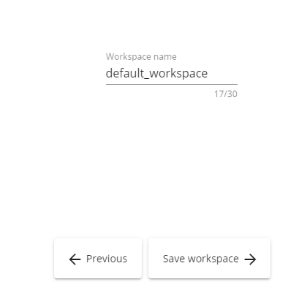

**Fig. 2.19. Saving of workspace**

**2.F Shutting Down**

To power off the Niryo Ned2 robot, access the settings menu in Niryo Studio and click on the "SHUTDOWN NIRYO ROBOT" button, as illustrated in Figure 2.20. It is recommended to first move the robotic arm to its home position by selecting the "BACK TO HOME" option under the "ARM COMMAND" tab in Niryo Studio, as shown in Figure 2.8. This precaution is necessary because if the arm is in any other position, it may collapse upon shutdown since the motors and their drivers will be deactivated.

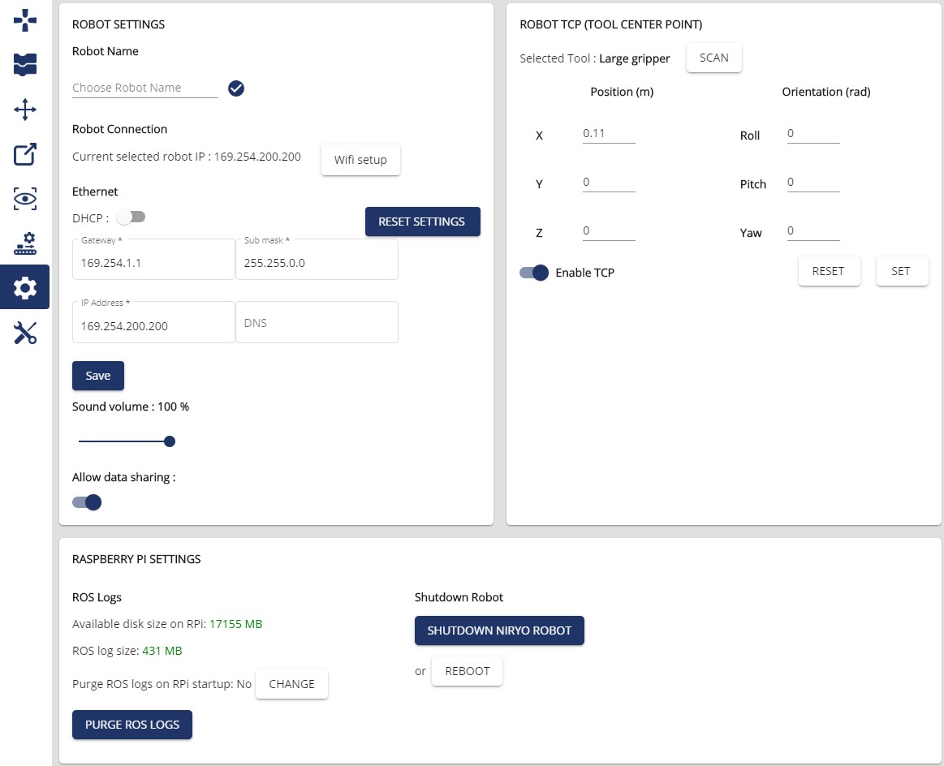



**Fig. 2.20. SHUTDOWN NIRYO ROBOT Button**